1. DOPLŇ SPRÁVNÉ NÁZVY JARNÍCH KVĚTIN DO KŘÍŽOVKY.

TAJENKA: __ __ __ __ __ __ __

(pozn.: musíš přeskládat písmenka, aby ti vyšla tajenka)

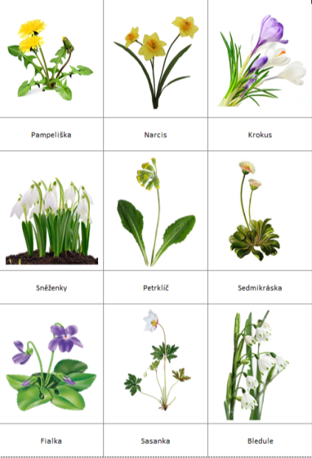

7.

5.

4.

1.

|  |  |  |  |  |  |  |  |  |  |  |  |  |  |  |  |
| --- | --- | --- | --- | --- | --- | --- | --- | --- | --- | --- | --- | --- | --- | --- | --- |
| **1** |  |  |  |  |  |  |  |  |  |  |  |  |  |  |  |
| **2** |  |  |  |  |  |  |  |  |  |  |  |  |  |  |  |
| **3** |  |  |  |  |  |  |  |  |  |  |  |  |  |  |  |
| **4** |  |  |  |  |  |  |  |  |  |  |  |  |  |  |  |
| **5** |  |  |  |  |  |  |  |  |  |  |  |  |  |  |  |
| **6** |  |  |  |  |  |  |  |  |  |  |  |  |  |  |  |
| **7** |  |  |  |  |  |  |  |  |  |  |  |  |  |  |  |



6.

3.

2.